DANGER School

With below database schema of DANGER School, we will join the tables and select data accordingly with SQL:

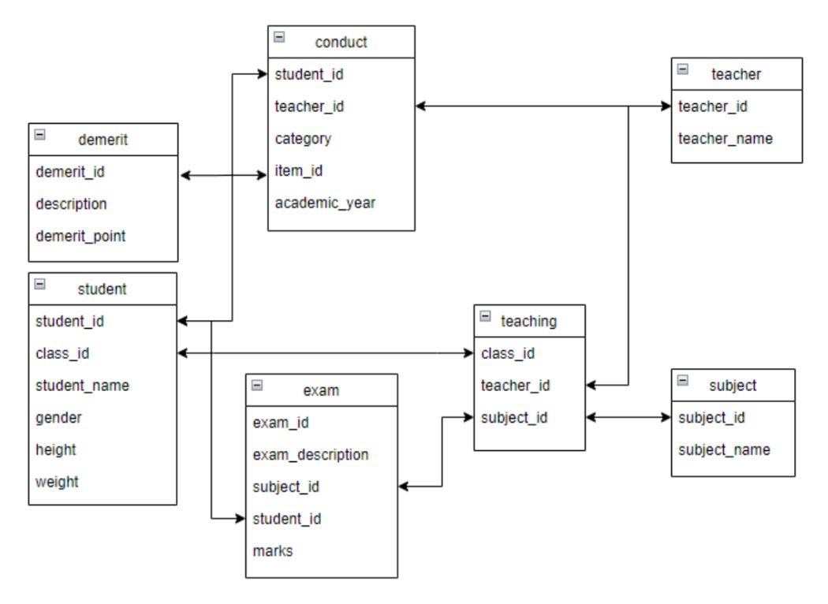

Q1.
Select a table including below columns:
- class id
- subject name
- teacher name

Q1. Answer:
select
teaching.class_id,
subject.subject_name,
teacher.teacher_name
from teaching
left join subject on teaching.subject_id = subject.subject_id
left join teacher on teaching.teacher_id = teacher.teacher_id

Q2.
Select a table including below columns:
- exam marks
- student height

Q2.Answer
select
exam.marks,
student.height
from exam
left join student on exam.student_id = student.student_id

Q3.
Select a table including below columns:
- exam id
- exam description
- subject id
- student id
- exam marks
- teacher name

Q3.Answer
select
exam.exam_id,
exam.exam_description,
exam.subject_id,
exam.student_id,
exam.marks,
teacher.teacher_name
from exam
left join student on exam.student_id = student.student_id
left join teaching
on exam.subject_id = teaching.subject_id and student.class_id = teaching.class_id
left join teacher on teaching.teacher_id = teacher.teacher_id

Q4.
Select a table including below columns:
- student name
- exam description
- exam marks
- subject name
- teacher name

Q4.Answer
select
student.student_name,
exam.exam_description,
exam.marks,
subject.subject_name,
teacher.teacher_name
from exam
left join student on student.student_id = exam.student_id
left join teaching on exam.subject_id = teaching.subject_id and student.class_id = teaching.class_id
left join subject on teaching.subject_id = subject.subject_id
left join teacher on teaching.teacher_id = teacher.teacher_id

Q5.
Calculate BMI for each student with below columns:
- student name
- BMI (i.e. BMI = weight(kg) / height(m)^2)

Q5. Answer
select
student.student_name,
student.weight/((student.height/100.0)^2) as BMI
from student

Level 2

Q1.
The highest mark of each teacher’s student scored

Q1. Answer
select
teaching.teacher_id,
teacher_name,
max(marks)
from exam
left join student on student.student_id = exam.student_id
left join teaching on teaching.subject_id = exam.subject_id and student.class_id = teaching.class_id
left join teacher on teaching.teacher_id = teacher.teacher_id
where student.class_id is not null
group by teaching.teacher_id, teacher_name

Q2.
Subject average marks on each examination

Q2. Answer
select
exam_id, subject_id, avg(marks)
from exam
group by exam_id, subject_id
order by exam_id, subject_id

Q3.
The student having the highest annual marks

Q3. Answer
select *
from student
where student_id = (
select
student_id
from exam
group by student_id
order by sum(marks) DESC
limit 1
)

Q4.
Number of students in each class

Q4. Answer
select
class_id,
count(*)
from student
group by class_id
order by class_id

Q5.
Teacher name of teacher who have given the highest number of demerit

Q5. Answer
select
teacher_name,
num_demerit
FROM (
select
teacher_name,
num_demerit,
RANK() over (order by num_demerit desc) rank
FROM
(
select
teacher_id,
count(*) num_demerit
from conduct
where category = 'Demerit'
group by teacher_id
) t1
LEFT JOIN teacher on teacher.teacher_id = t1.teacher_id
) as t
WHERE rank = 1

Q6.
The exam average mark of the naughtiest student

Q6. Answer
with naughtiest as (
select
student_id,
sum(demerit_point)
from conduct
left join demerit on conduct.item_id = demerit.demerit_id::text
where demerit_point is not null
group by student_id
order by sum DESC
limit 1
)

select avg(marks)
from exam
left join naughtiest on exam.student_id = naughtiest.student_id

